PreRequisites-IBMCloudServices

|  |  |
| --- | --- |
| **TEAM ID** | PNT2022TMID08484 |
| **ProjectName** | Gas lekage monitoring and alerting system |
| **LeaderName** | M. Ravinesan |
| **TeamMembersName** | M.sivanantham  R. Vijay  S. Sathish |

**DASHBOARD:**

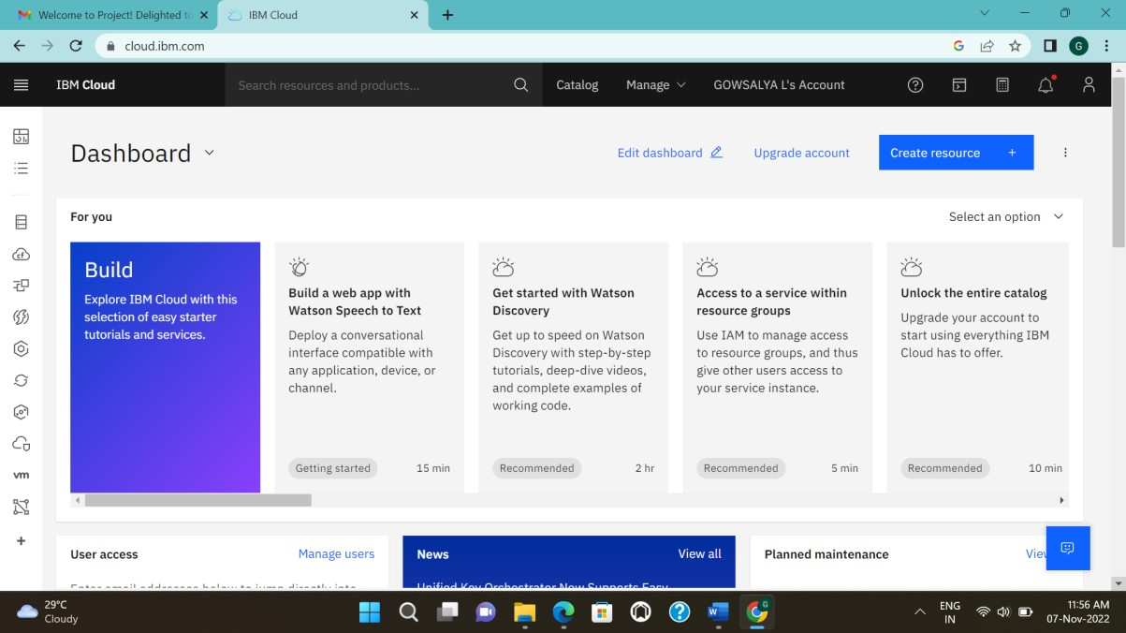

**ACCOUNTSETTINGS:**

